Detailed Report on Real-Time Language Based Selective Audio De-noising.
Project Overview:
This project implements a complete microservice-based object detection system using Ultralytics YOLOv8 and FastAPI.
The system consists of two independent but cooperating services:
- UI Backend Service (FastAPI)
  - Serves the frontend web interface
  - Accepts image uploads
  - Forwards uploaded images to the AI backend
  - Displays detection results in a clean UI
  - Uses Jinja2 templates for maintainable HTML structure
- AI Backend Service (FastAPI + YOLO)
  - Loads a lightweight YOLOv8 model
  - Performs object detection
  - Returns structured JSON
  - Also returns a base64-encoded annotated image
- These two services communicate via RESTful HTTP calls implemented using FastAPI, running inside Docker containers on a shared Docker network.

Project Architecture :
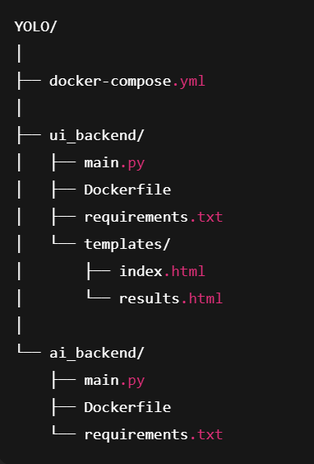

Technology Stack :
Component | Technology
Web-Framework | FastAPI
Inference Model | Ultralytics YOLOv8n
Inter-Service Communication | RESTful HTTP (POST)
Template rendering | Jinja2
Containerization | Docker+Docker Compose
Image Processing | OpenCV(Headless)
HTTP Client | HTTPX

Building the AI Backend Service :

Objectives
- Load YOLO model once during startup
- Accept uploaded images through /detect and /detect_with_image
- Return:
  - JSON detections
  - Annotated image (base64 encoded)
Key Features
- YOLO("yolov8n.pt") loads a lightweight model
- results = model(img)[0] performs inference
- results.plot() produces the annotated frame
- Base64 encoding used to send image through JSON safely
Challenges & Fixes:
Issue | Fix
OpenCV required libGL.so.1 | Used opencv-python-headless (no GUI libs needed)
Multipart Errors | Installed python-multipart
Repeated heavy torch downloads | Cached layers; kept layers minimal
Jinja errors in UI | Not applicable to AI backend

Building the UI Backend Service :

Goals
- Present a clean web user interface
- Allow file upload
- Forward the image to AI backend
- Display both JSON and annotated image in a user-friendly layout
Challenges & Fixes
Issue | Fix
Python f-string error: unhashable dict | Moved dict parsing outside templates
Jinja2 not installed | Added jinja2 to ui requirements
Multipart form errors | Installed python-multipart
Inline HTML messy | Moved to Jinja templates
Dockerizing Both Services :

Files Created:
- ui_backend/Dockerfile
- ai_backend/Dockerfile
- docker-compose.yml
We used:
- python:3.11-slim for minimal image size
- pip install --no-cache-dir for clean builds
- Separate requirements for each microservice

docker-compose responsibilities:
- Building both containers
- Creating internal Docker network
- Exposing:
  - UI backend → localhost:8000
  - AI backend → localhost:8001
- Ensuring proper container startup order
Reference:
https://docs.docker.com/reference/compose-file/
Final Data Flow:
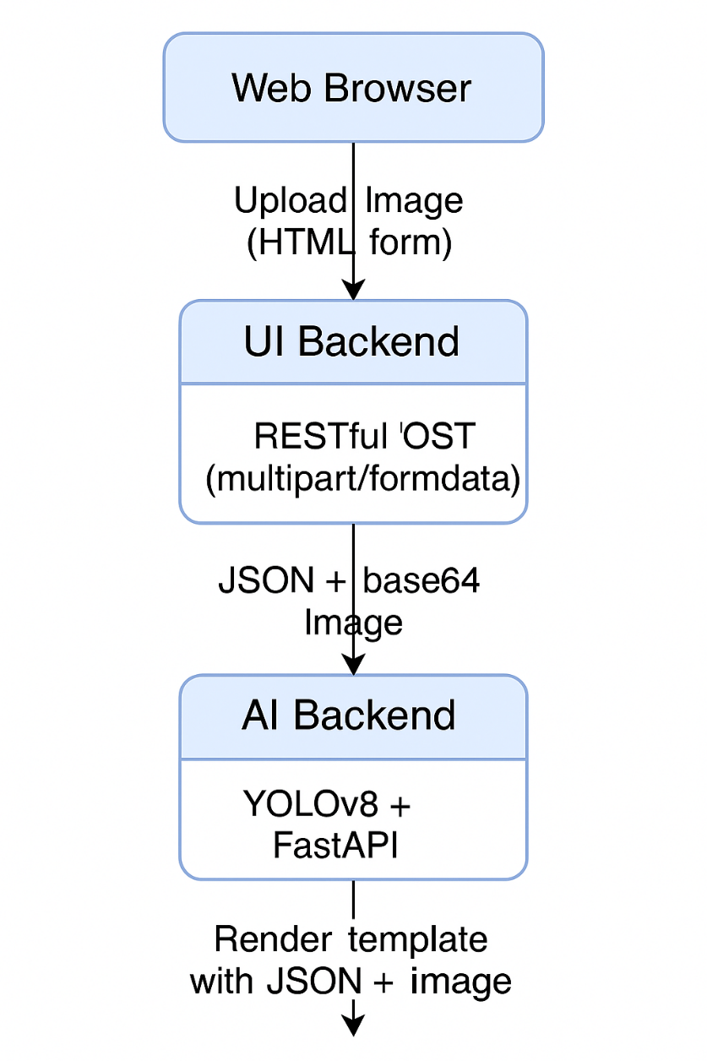

Final Output :

JSON Output
- Class IDs
- Class names
- Confidence scores
- Bounding box coordinates

Annotated Image
- Bounding boxes drawn on the uploaded image
- Shown in UI via a separate tab
- Delivered using base64 to avoid file handling

Web UI
- Upload form
- Tidy modern interface
- Results displayed with tabs

References Used

Docker Documentation - https://docs.docker.com/reference/

FastAPI Documentation - https://fastapi.tiangolo.com/

Ultralytics YOLOv8 Documentation - https://docs.ultralytics.com/models/yolov8/

Starlette Templating (FastAPI Templates) - https://www.starlette.io/templates/

HTTPX - https://www.python-httpx.org/

Conclusion
This project demonstrates a production-quality microservice architecture for real-time object detection:
✔ FastAPI front-end and back-end
✔ Stateless REST communication
✔ Ultralytics YOLOv8 inference
✔ Clean UI with Jinja2 templates
✔ Docker containerization
✔ Strong modular separation
✔ Fully reproducible and extensible
This architecture is suitable for:
- cloud deployment
- ML inference pipelines
- backend integration with mobile/web apps
- extending to segmentation, classification, or multi-model setups
--------------------------------------------------------xxxxxxxx-------------------------------------------------

